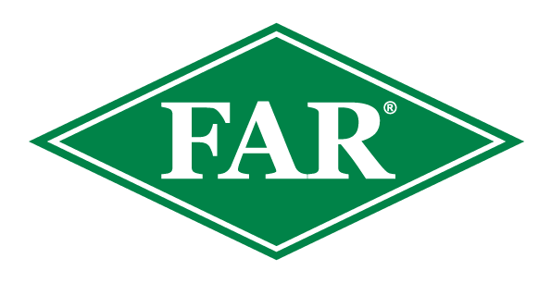

Fall armyworm update
12th^{th} May 2024
Key points
Since the last update on the 19th of April 2024, there have been two new confirmed finds, both from Northland. In the 2023/24 growing season, there have been 113 confirmed reports from Northland, Westland, Tasman, Bay of Plenty, Auckland, Waikato, Marlborough, and Canterbury.

- Northland FAW moth flights are still being observed in pheromone traps consistently, however moth numbers are falling. Adult FAW have the potential to travel significant distances in one flight, and in the absence of maize they may travel inter-regionally to seek suitable locations to mate and initiate the next generation. If you have been monitoring traps, please keep checking them even after your crop has been harvested.
- Many susceptible crops around the country have been harvested (or are close to harvest) meaning a reduction in FAW’s preferred food source.
- Maize grain crops are still at risk, FAW larvae will typically enter the cob through the side, unlike Corn earworm (Helicoverpa armigera) which enter via the silks and the top of the cob. Observations of population dynamics and kernel damage will be beneficial to help develop NZ-specific economic damage thresholds.
- As temperatures are decreasing, the life cycle has begun to slow, and along with a reduction in surveillance, it is important to stay vigilant and scout harvested and any neighbouring paddocks as FAW will predate a large variety of crops. In NZ they have been observed on ryegrass and clover in a harvested maize paddock. Crop residues should not be overlooked, neither should any volunteer maize that may emerge in the coming weeks or months.
- FAW will feed on a large variety of crops in the absence of maize and sweetcorn, research has shown they will happily travel to an acceptable alternate host.
- The insecticide Sparta® is on label for aerial and ground applications for controlling fall armyworm on maize and sweetcorn crops. Consult your advisor.
At this date last year there were 139 fall armyworm finds nationwide, including Northland, Auckland, Waikato and Taranaki and Canterbury.

The Fall Armyworm Response in New Zealand ended one year ago on the 21st April 2023
If you are scouting crops please inform us; even if you do not find FAW, this population data is useful. The data provided to date has been fantastic. It will support FAW modelling and has been extremely helpful for ongoing work developing predictive tools and understanding FAW in New Zealand’s unique arable environments.
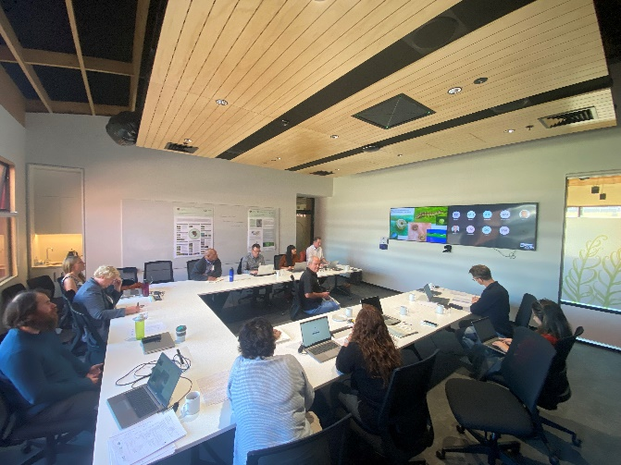
NZ FAW Research Meeting.
Photo – Dr Graham Walker giving a talk on the importance of Cotesia spp, maize pest dynamics and effects of pyrethroids on beneficial insects.

Along with AgResearch and Plant & Food Research, FAR organised a Fall Armyworm research workshop. This enabled the sharing of existing work, future projects, collaboration potential and discussion of all things FAW-related in NZ.

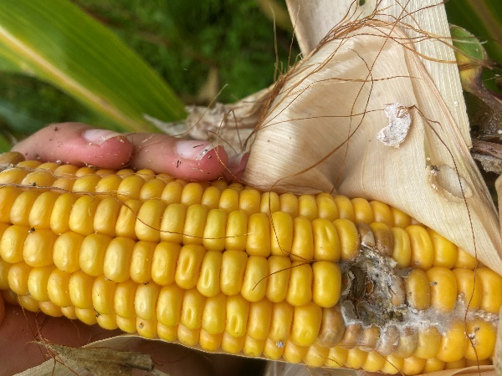
Cob Damage
Recent scouting in maize grain crops in the north island has seen small populations of FAW entering the cob and eating kernels. Even when the damage from FAW is minimal, the cob is exposed to the potential of diseases that can further reduce yield. Looking at this photo, the FAW larvae may have only destroyed 6-8 kernels, but the fungi present may cause much more damage to this cob before harvest.

Beneficial Insects
Cotesia spp
This recent photo shows the cocoons of parasitic wasps in a maize grain crop. Cotesia ruficrus has been an extremely effective biocontrol for Cosmopolitan armyworm since its release in the early 1970’s. keep an eye out for these cocoon masses, they are widespread across NZ and have been predating FAW since it arrived in 2022.

The end of autumn and winter is a great time to plant natives that will provide refuge to these key beneficial insects that we know have been reducing FAW and other pest numbers. This Plant & Food Research podcast is extremely useful and will hopefully get you thinking about increasing the biodiversity of your property to benefit the beneficial insects in our farming environment.
Fresh findings on beneficial insects · Plant & Food Research (plantandfood.com)

What to do if you think you find fall armyworm
Photograph it: FAW can be easily mistaken for other species, so if you suspect it, take a good quality photo, and be sure to include the head, body and rear of the larvae. This can be in multiple photos if necessary. This guide from the Queensland Department of Agriculture and Fisheries outlines how to take photos of FAW.
Catch it: Samples are important for positive identification and testing.
Contact us: Contact the Foundation for Arable Research at far@far.org.nz or Biosecurity Officer Ash Mills at ashley.mills@far.org.nz
Trap network and active scouting and reporting have been fantastic throughout the season and are much appreciated.
- All data recorded (even zero finds) are valuable for the validation of modelling platforms and for understanding the pest in New Zealand.
- If you are keen to monitor a trap and share scouting information please get in touch.
- Data and observations of parasitism as well as potential relationships with other pest species would also be welcomed.

Consult the FAR website for the latest resources and identification guides
FAR Research | Welcome to the Foundation for Arable Research
Listed below are useful updates, tools and guides on detection and identification
FAR Research | Fall armyworm identification and background
FAW larval identification guide (publications.qld.gov.au)
For advice around Sparta, FAW information and requesting a great FAW glovebox guide - Fall Armyworm (corteva.co.nz) and this FAW Sparta technote Salesforce
Thresholds for economic damage
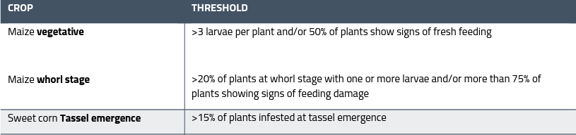
Plant Health Australia provides useful guidance for this:

Useful insight from over the ditch - https://www.planthealthaustralia.com.au/fall-armyworm/
SGRR Davis Scale Guide - 86d44eb4-7d19-5ce5-befe-4dd32eeca38c.pdf (far.org.nz)

A farm Biosecurity Register is a great way of reducing the risk of unwanted weeds, pests and diseases arriving on your doorstep. Do you have one? Find out more here FAR Research | Arable Biosecurity Risk Register

